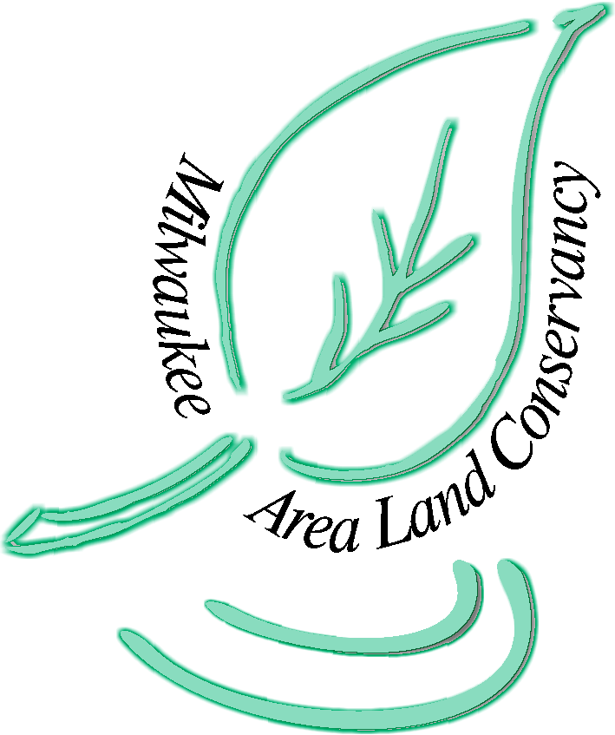
Pledge Form

Milwaukee Area Land Conservancy

Donor Information (please print or type)
Name
Billing address
City
State
ZIP Code
Telephone (home)
Telephone (business)
Fax
E-Mail

Pledge Information
I (we) pledge a total of $_______________to be paid:
____ now ____ monthly ____ quarterly ____ yearly.
I (we) plan to make this contribution in the form of:
____ cash ____ check ____ other.
Gift will be matched by ________________________________ (company/family/foundation).
____ form enclosed ____ form will be forwarded

Acknowledgement Information
Please use the following name(s) in all acknowledgements:
____ I (we) wish to have our gift remain anonymous.
Signature(s)
Date
Please make checks, corporate matches, or other gifts payable to:
Milwaukee Area Land Conservancy
P.O. Box 320304
Franklin, Wisconsin 53132

